**Daily Scrum or Standup Meeting**

Team name: Alpha Squad

Scrum Master: Alex Beeston

Date: November 6, 2019

|  |  |  |  |
| --- | --- | --- | --- |
| **Team Member** | **What did you do since the last scrum?** | **What do you plan to do before the next scrum?** | **What obstacles do you have?** |
| Alex Beeston | Allowed the admin to cycle through the live items; validate that the auctioneer inputs a valid auction-number | Don’t have anything to work on ATM except styling the pages. Might save that for next sprint | NA |
| Joey Carlisle | Worked on the init_test_db view  it now nukes the database | Finish the create item for both live and silent pages | the migrations keeps being annoying to me |
| Isaak Johnson | Turned my python code into django code and simplified it | Don’t have anything to work on ATM | None |
| Ben Taylor | Finished the user and payment page. | I don’t know, I need something to do before our next meeting | None |

# Burndown

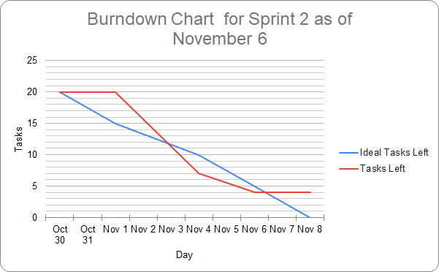

# Screenshot of you project board

